**Analysis of New Zealand Visitor Trends by Time Span and Country of Origin**

**Introduction**

This report combines two critical perspectives on New Zealand’s inbound tourism: the seasonal trends (time span analysis) and visitor patterns by country of origin. Leveraging statistical analysis and R programming, this study provides insights into how seasonal factors influence visitor numbers and highlights the recovery of critical international markets post-pandemic. By examining the data from 2003 to 2024, focusing on the period leading up to March 2020 (pre-COVID-19), the report identifies key trends and offers recommendations for future tourism development strategies.

**Time Span Analysis: Seasonal Impact on Visitor Numbers (2003–2024)**

1. Overall Trends (2003–2024)

The time series analysis of visitor arrivals to New Zealand between 2003 and 2024 reveals a clear seasonal pattern, with peaks in visitor numbers during the summer months and significant declines during winter. The linear regression model across the entire time span shows the following:

* **Summer**: The baseline season, with an average of 167,296 visitors.
* **Autumn**: A reduction of 69,800 visitors compared to summer.
* **Winter**: A significant decrease, with 98,466 fewer visitors compared to summer.
* **Spring**: A decrease of 66,085 visitors compared to summer.

The adjusted R-squared value of 0.327 suggests that while seasonality is an important factor, other elements, such as external shocks (e.g., the pandemic), also play a role in shaping visitor trends, especially in recent years​(ts-report draft).

1. Pre-COVID-19 Trends (2003–March 2020)

Focusing on the period before March 2020, the seasonal impact becomes more pronounced. The linear regression model for this period shows that:

* **Summer**: Visitor numbers peaked at an average of 185,689.
* **Autumn**: A decrease of 74,831 visitors compared to summer.
* **Winter**: The most significant decline, with 107,126 fewer visitors.
* **Spring**: A decrease of 71,970 visitors.

The adjusted R-squared value of 0.522 indicates that seasons accounted for over 50% of the variation in visitor numbers before the pandemic. This higher value suggests that seasonality was the dominant factor influencing tourist arrivals before external disruptions like COVID-19​(ts-report draft).

1. Post-COVID-19 Patterns

As the time series plot indicates, the post-pandemic era (2020–2024) exhibits irregular visitor trends, with a sharp decline in 2020 followed by an uneven recovery. The seasonal solid effect observed in previous years appears disrupted by travel restrictions and shifting global travel behaviour. This shift necessitates an adaptive tourism strategy that accounts for seasonal and external factors.

**Country of Origin Analysis (2020–2024)**

1. Key Findings

The analysis of visitor arrivals by country of origin from 2020 to 2024 reveals essential insights about the recovery trajectories of different markets post-pandemic:

* **Australia**: Continues to lead as the largest source of visitors. Visitor numbers dipped significantly in 2021 due to the pandemic but rebounded strongly by 2023 and 2024.
* **United States and United Kingdom**: Both countries exhibited a strong recovery after 2022, with steady growth in 2023 and 2024.
* **China**: Demonstrated the fastest growth rate among non-English-speaking countries, rebounding sharply from the low point in 2021.
* **European Countries**: Germany and France showed slower but consistent growth in tourist arrivals​(subtopic- by country).

1. Yearly Growth Rates and Insights

* **Australia and the United States** showed the highest recovery rates after 2021, indicating that these markets are critical for New Zealand’s tourism revival. Their growth was particularly significant in 2023 and 2024.
* **China**: The fastest-growing market post-2022, making it a priority for targeted marketing and service customization.
* **Europe**: Countries such as Germany and the U.K. maintained stable growth, though at a slower pace than the U.S. and China.
* **Japan and South Korea**: Steady recovery in tourist numbers highlights the importance of these markets moving forward​(subtopic- by country).

**Recommendations**

1. **Seasonal Tourism Management & Adapt to Post-Pandemic Dynamics**
   * **Summer Tourism**: With summer continuing to attract the most visitors, investments should focus on managing peak demand. Expanding infrastructure to cope with high visitor volumes and offering premium experiences during this season can enhance visitor satisfaction.
   * **Year-Round Tourism**: Given the irregular recovery patterns after COVID-19, New Zealand must promote year-round tourism with flexible travel options. Encouraging seasonal discounts can help maintain visitor numbers even during off-peak seasons.
   * **Health and Safety**: As post-pandemic tourists may prioritize health and safety, ensuring that New Zealand is marketed as a safe destination will attract a broader range of international visitors.
2. **Target Non-English-Speaking Markets**
   * **Multilingual Services**: The growing number of visitors from China, Japan, and Germany necessitates enhanced language support. Providing multilingual signage, translation services, and tailored tour packages for these markets will improve visitor experiences and encourage repeat visits.
   * **Customized Travel Experiences**: Catering to the cultural preferences of key markets, such as offering adventure tours for German tourists and shopping tours for Chinese visitors, will increase satisfaction and spending.
3. **Strategic Marketing and Resource Allocation**
   * **Australia and U.S. Focus**: With Australia remaining the largest visitor market, continuing to invest in infrastructure and services tailored to Australian tourists is crucial. Similarly, the U.S. market, particularly in the luxury segment, should be prioritized with investments in high-end resorts and experiences.
   * **Chinese Market Expansion**: China’s rapid post-pandemic growth suggests the need for targeted marketing campaigns, particularly on platforms like WeChat and Xiaohongshu (Little Red Book), popular among younger Chinese travellers​(subtopic- by country).
4. **Infrastructure and Digital Innovation**
   * **Foreign Language Guides**: The increasing demand for foreign language guides, especially from China, Japan, and Germany, requires investment in multilingual training for tour operators and the developing of digital guides and apps.
   * **Sustainable Tourism Initiatives**: Developing eco-friendly tourism options and promoting New Zealand’s natural beauty to environmentally conscious travellers will attract visitors during peak and off-peak seasons​(subtopic- by country).

**Conclusion**

The findings from this report indicate that while seasonality remains a crucial factor influencing visitor arrivals in New Zealand, post-pandemic dynamics have introduced new challenges and opportunities. By adapting to these changes, focusing on emerging markets like China and maintaining high service standards, New Zealand can sustainably grow its tourism industry. Offering year-round attractions and enhancing digital and multilingual services will ensure that New Zealand remains a competitive and appealing destination for international visitors.

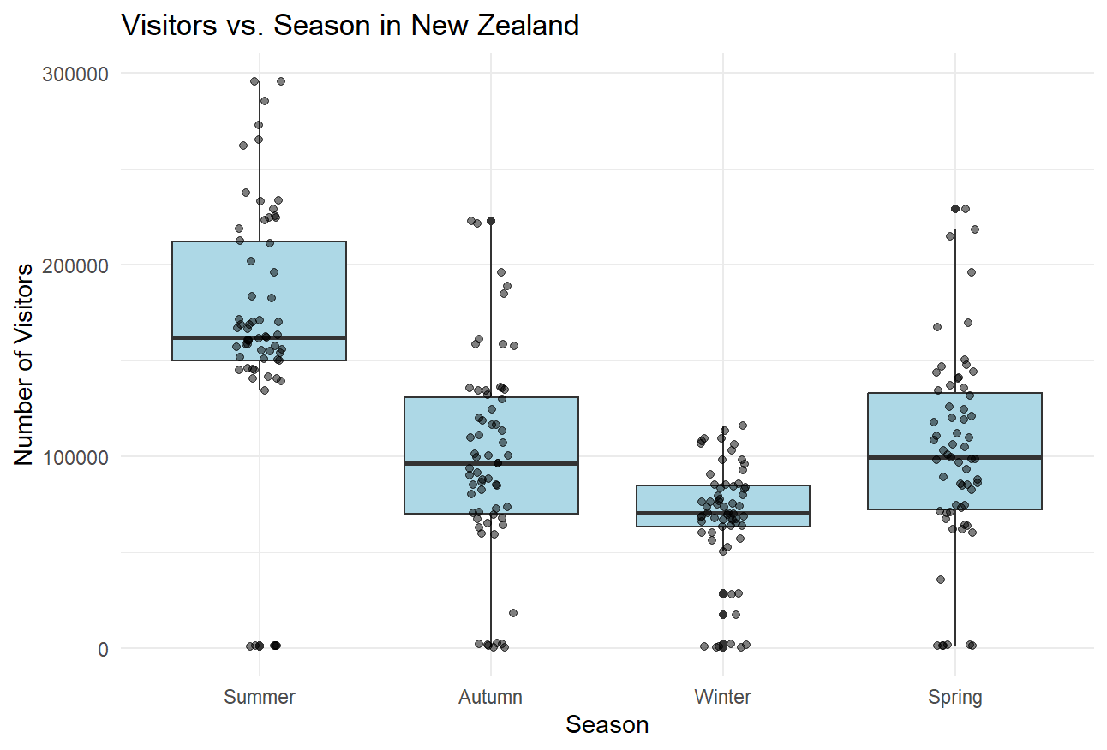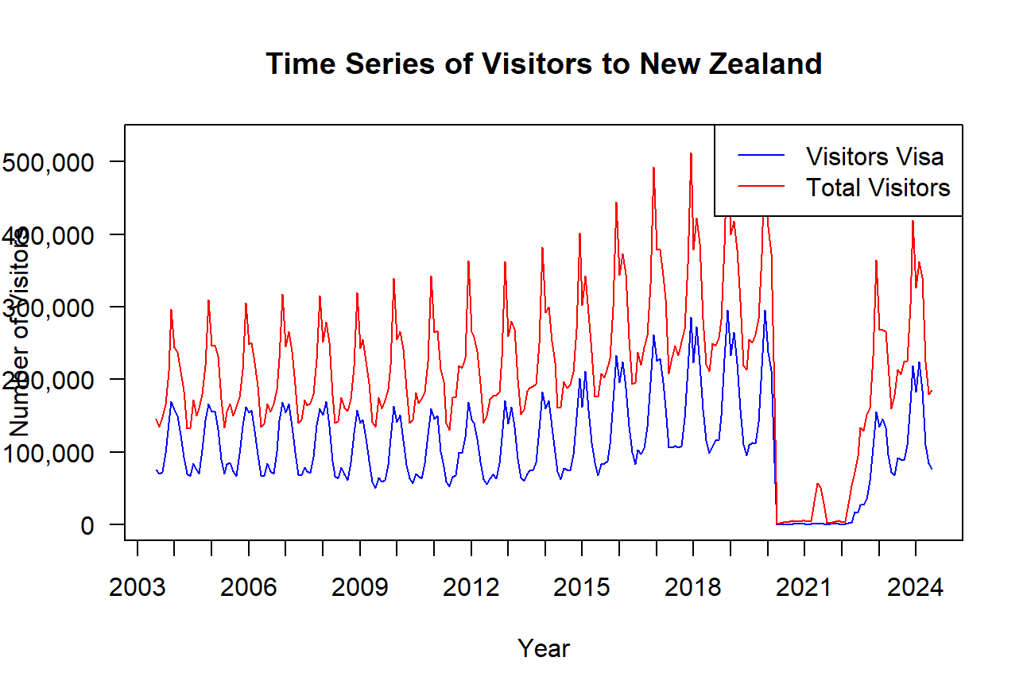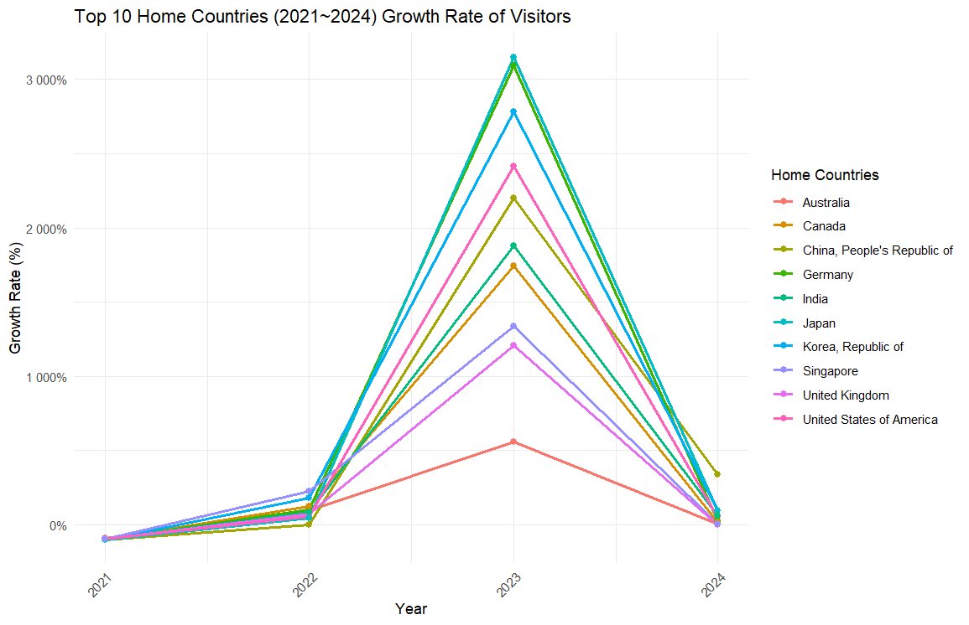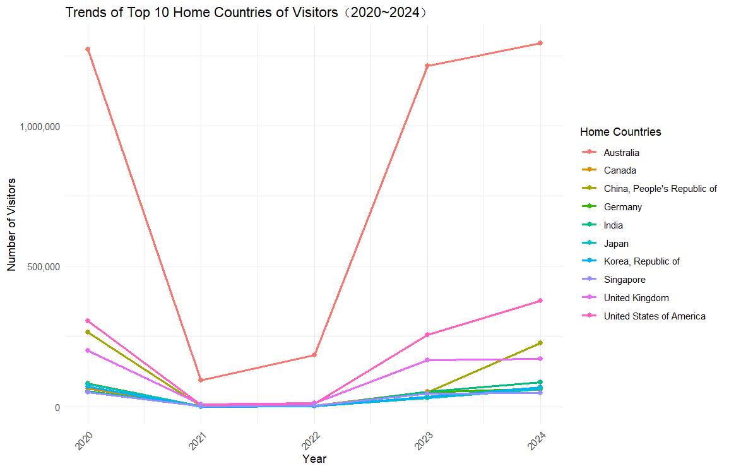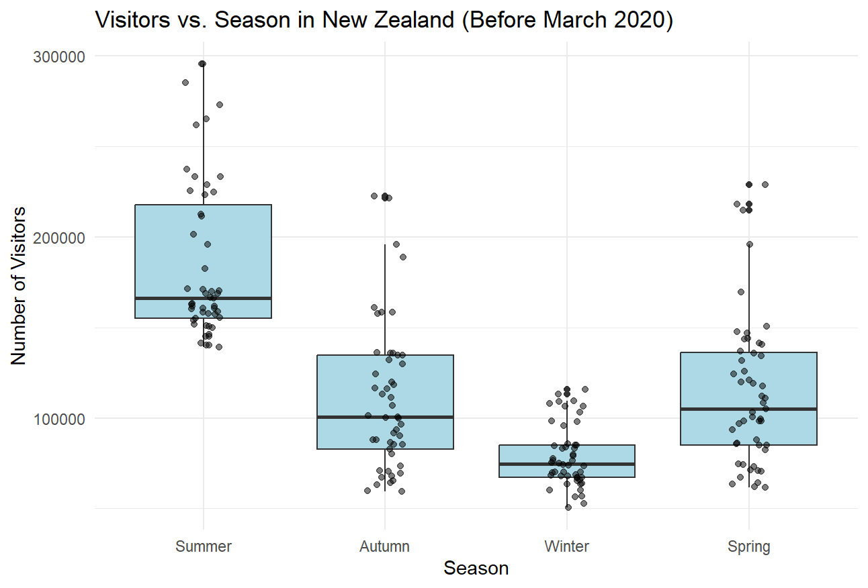

LM on season (the whole time span from 2003~2024):

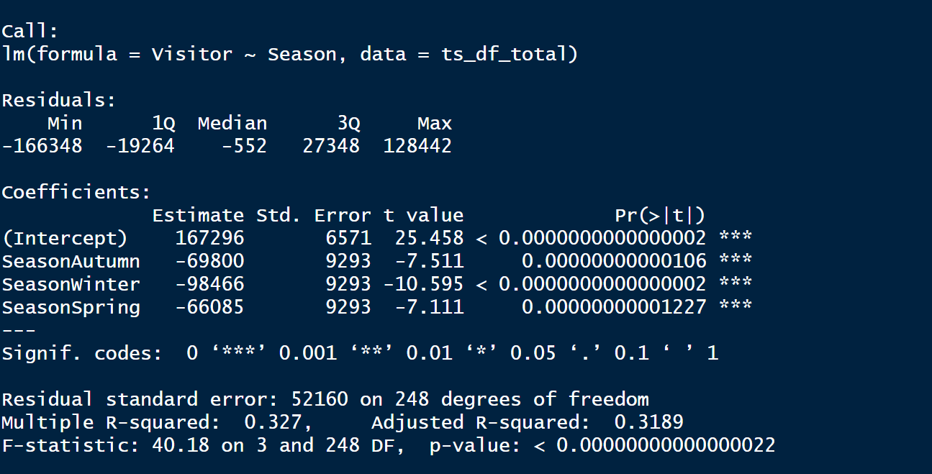

LM on season (before Covid):

